Given a string containing digits from 2-9 inclusive, return all possible letter combinations that the number could represent.

A mapping of digit to letters (just like on the telephone buttons) is given below. Note that 1 does not map to any letters.

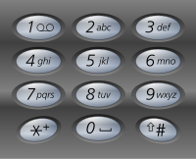

**Example:**

**Input:** "23"

**Output:** ["ad", "ae", "af", "bd", "be", "bf", "cd", "ce", "cf"].